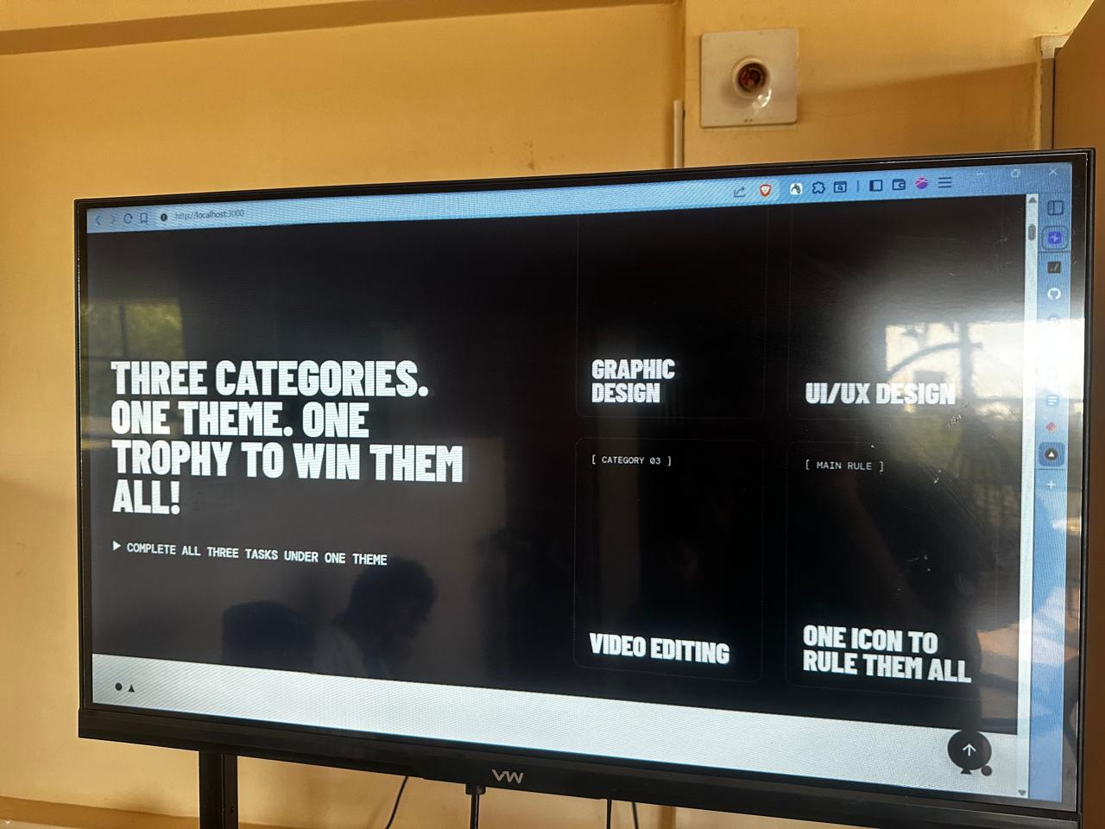

**Categories:**   
  
Articon Champion | Graphic Designer | UI/UX Designer | Video Editor

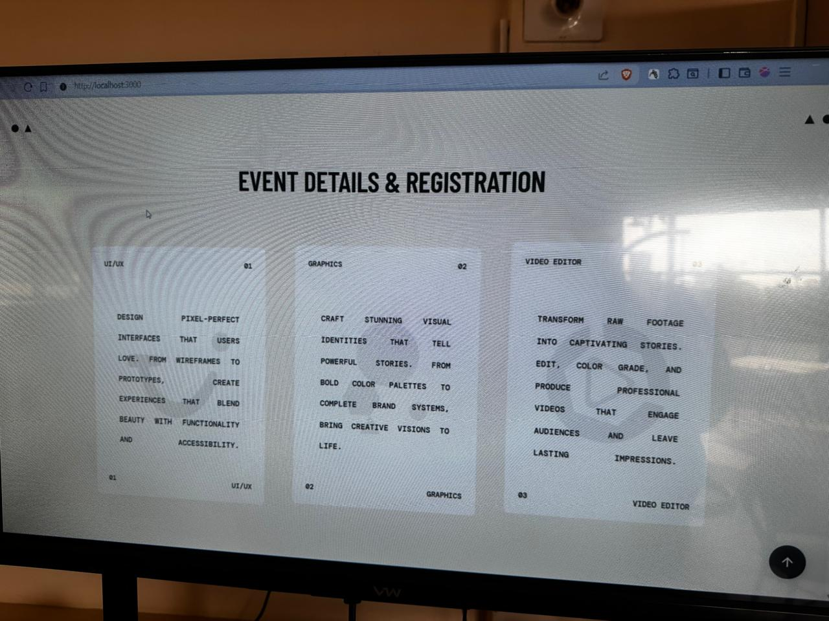

**Event Details & Registration**

**What we expect**

Graphic Designer

* Creative
* Detail-oriented
* Brand-focused
* Skilled in design tools
* Visual communicator
* Deadline-driven

Video Editor

* Sharp Timing
* Prompt Expert
* Smooth Flow
* Story Driven
* AI-Savvy
* Fast & Efficient

UIUX

• User-Focused

* Wireframe Pro
* Clean Layout Mindset
* Strong UX Logic
* Interactive Thinking
* Data-Driven Decisions

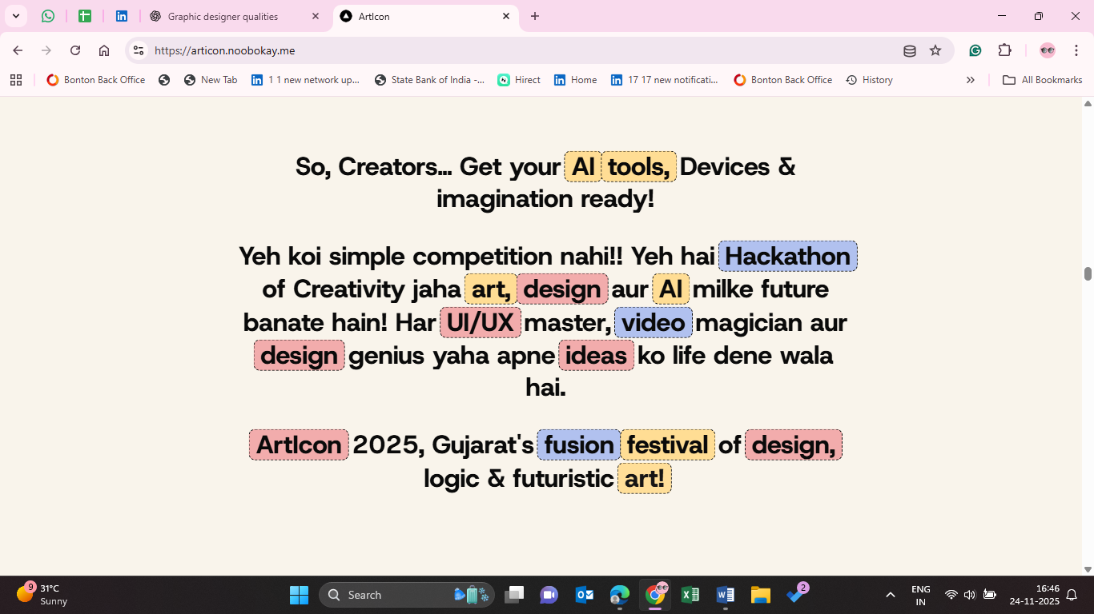

**Who will be the ArtIcon Champion?**

The one who performs in all **3 categories** and delivers the **best creative results** across:

* Graphic Design
* UI/UX
* Video Editing

Only the most versatile, innovative, and consistent creator will take home the **ArtIcon Champion Title**

So creators…  
Bring your AI tools, devices & imagination!

This isn’t just a competition   
it’s a creativity explosion where art, design & AI shape the future!  
Whether you're a UI/UX thinker, Graphic designer, or Video editor wizard   
your ideas come alive here!

**ArtIcon 2025 Gujarat’s FIRST AI-powered creativity competition**

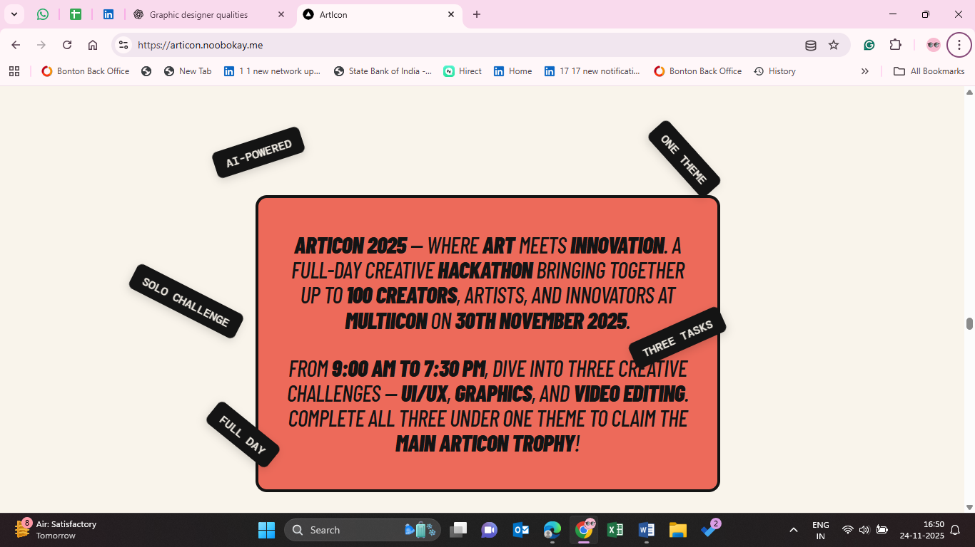

**Sunday, 7 Dec 2025 - 9:00 AM**  
**Be ready to unleash your creativity!**

**After Register**

**Subject:** Registration Received — Portfolio Under Review

Hello,  
Your registration for ArtIcon 2025 is successfully completed. 🎉  
Our team will now review your portfolio and we’ll notify you of the status soon.

Thank you for your interest & participation!  
— Team ArtIcon

**After Portfolio approve**

**Subject:** Congratulations You’re Selected for ArtIcon 2025!  
  
Great news! 🎉  
Your portfolio has been reviewed and you have been **APPROVED** to participate in ArtIcon 2025.

📅 Date: Sunday, 7th December 2025  
⏰ Time: 9:00 AM  
📍 Floor 3, Rumi Plaza, Airport Main Rd, near Race Course Road, Maruti Nagar, Rajkot, Gujarat 360001

We’re excited to see your creativity in action!  
—Team ArtIcon

**NOT SELECTED  
  
Subject:** ArtIcon 2025 — Application Update

Hello,  
Thank you for your interest in ArtIcon 2025. After reviewing your portfolio, we regret to inform you that you were **not selected this time**.

We truly appreciate your effort and encourage you to participate in future events — your creativity matters!

Thank you for understanding.  
— Team ArtIcon

**Reminder — 2 Days Before**

**WhatsApp / Email:**  
Just a reminder — ArtIcon is in 2 days! Get your creativity ready 🎨🤖  
See you soon!

**⏰ Reminder — 1 Day Before**

**WhatsApp / Email:**  
Tomorrow is the big day! 🌟  
ArtIcon starts at 9:00 AM.

**⏰ Reminder — Same Morning**

**WhatsApp / Email:**  
Good Morning! ☀️  
Today is ArtIcon Day!  
See you at 9:00 AM don’t forget your tools & energy ⚡